Docker : Docker is containerization platform that allow developer to packages, ship and run application in container.
Container are lightweighted and portable, provide consistence and reliable way to deploy application across different environment (OS or Server Machines)

All developer use Window OS with Java Application develop using Java version 17 and database mysql 8.x version.

Server machine may be window or Non Window

Virtualization: VM (Virtual Machine)
VMWare Software : allow us to run more than OS of any types.
Virtualization is responsible to run abstract version on an OS.
Containerization : is responsible to run abstract version of an Application.

Docker is responsible to run any application without installed any software in our local or server machine.

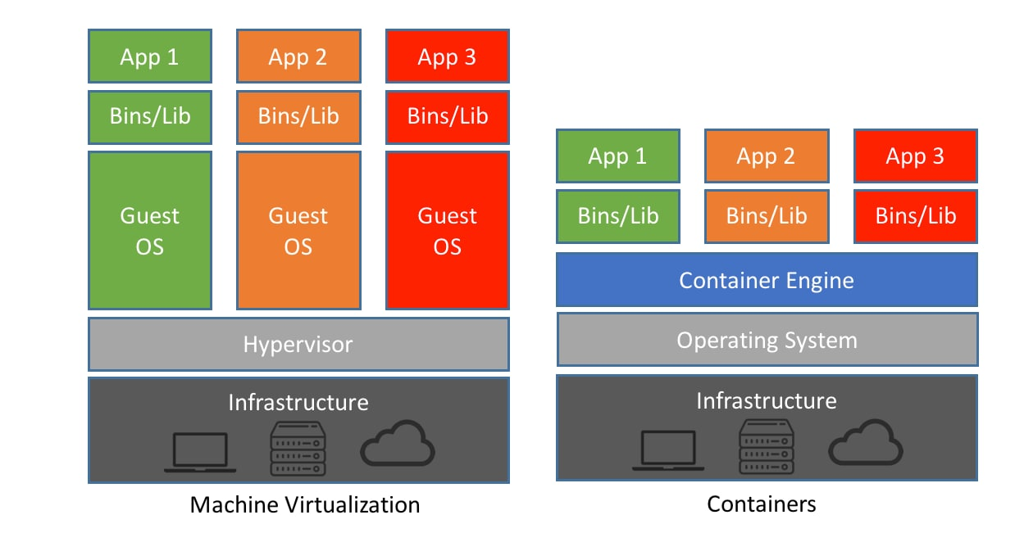

Key Concept for Docker
- Container : it is a light weighted and isolated environment that run the application develop using any language on any OS. But that OS must be present Docker engine.
- Docker images : it is ready only template file which help to run the application using Docker container.
- Dockerfile : this file contains set of instruction which help to create the image. Inside this file we need to provide application details and supporting dependencies to run the application. Using this file we can create the images.
- Docker hub : it is like a github. But in Docker hub we can publish or push more than one image. To other team pull the image and run in their local machine.

Docker desktop is a software run the images
https://docs.docker.com/desktop/setup/install/windows-install/

Docker hub : it is use to pull and push images

https://hub.docker.com/

DevOps

Git, maven, docker etc

Docker commands

docker --version it use to check the version of the docker

docker info it provide information about the docker

